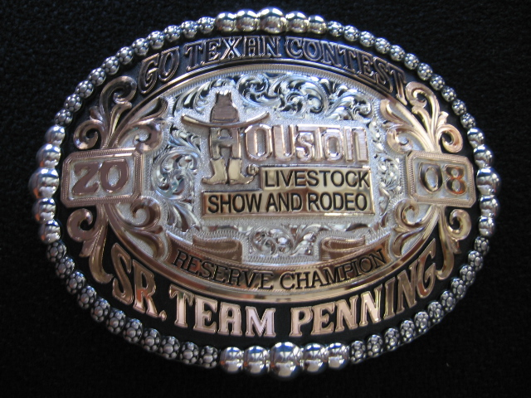

- Size – oval 2 ½” X 3 ¼”
- Replace top ribbon words, “Go Texan Contest” with “U Haul Em – We Stall Em”
- Replace words on ribbon “RESERVE CHAMPION” with my name: Ken Barrett
- Replace words on bottom ribbon “SR. TEAM PENNING” with LIVERY TEAM
- Eliminate the date boxes 20 and 08
- Same railed letters, same black background, same gold and silver colors as in photo

